Posted January 21, 2013 by Gavin Hoey in Articles
5 Things Top photographers do & the rest of us don’t
At some time or another we’ve all looked at the work of top photographers and wondered… What makes their photos better then mine? Is it because they use the best camera gear, work with the best models or get access to locations that mere mortals like us can only dream of? Well perhaps but here are five things top photographers do that may be you and I don’t.
1 Fill the frame
From landscape photographers to portrait photographers there’s one thing that all top photographers know and that’s to fill the frame with your subject. Now I’m not talking about simply zooming or cropping in closer, although that can be one solution. I’m talking realising what’s important to your photo as you’re looking through the viewfinder and pressing the shutter when the composition is exactly what you want
Top Tip: If it’s not part of the story, don’t have it in your photo.
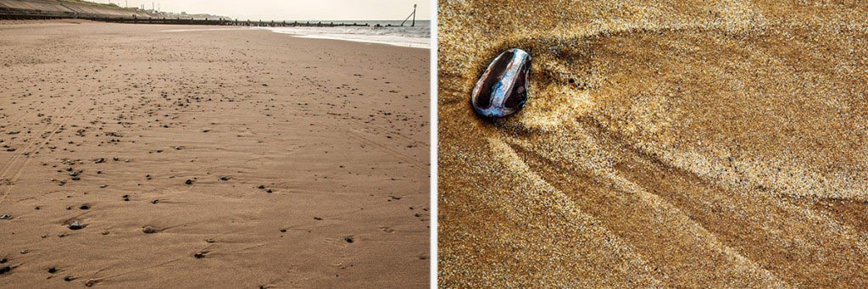
2 Revisit a location/subject
Like all photographers I look at the work of my peers and wish I could shoot an image even half as good. From time to time I’ve even gone to the same location to try and recreate the photo. Sadly it’s never quite the same.
So how do top photographers get great photos? They return to the shot again and again and again until they get it right. Each time they learn a little more about where to shoot, when to photograph and what makes a good image. You may have to visit the same location a dozen times before you get the perfect light, or shoot at the same sporting venue many times to discover the best vantage points.
Top Tip: If at first you don’t succeed… go back and do it again
3 Specialise on a subject
Many photographers flit from one type of photography to another. One day they’re trying to master landscape photography the next they’re trying their hand at shooting weddings. There’s absolutely nothing wrong with mixing it up but try to specialise in one area more then any other.
The fact is top photographers tend to become well known for not for shooting one area of photography but for being the best at a small niche of one area in photography. For example great fashion photographers don’t make great wedding photographers. Motor sports photographers may be rubbish at shooting football.
Top Tip: You only need to be the best in one area of photography
4 Learn from failure
All photographers have bad days and most of us have bad weeks too. Sometimes nothing goes your way. Maybe the weather doesn’t play ball or you accidentally shoot with the wrong exposure or perhaps you just run out of ideas.
When that happens, it’s natural to feel down hearted, frustrated and ready to throw in the towel. Top photographers will quickly get over the initial disappointment and the best photographers will embrace failure as all part of learning.
Going further, top photographer will expect to mess up and they’ll plan accordingly. Things like taking more then one photo, moving the view point, bracketing exposure and experimenting with lens choice are all part of the secret of success.
Top Tip: You’re the only one who will ever see your bad shots.

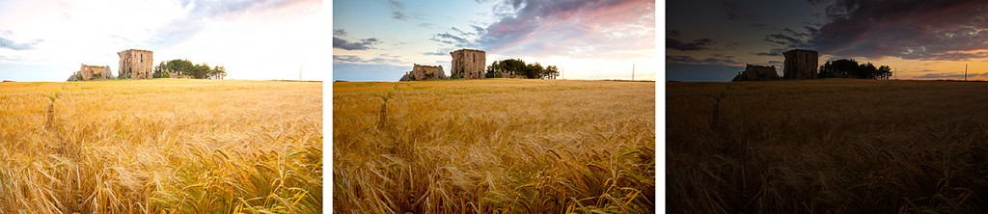

5 Think about post processing whilst taking photos
Let’s be honest, every photographer aims to get the photo right in the camera most of the time. We all know that Photoshop can do amazing things to help to fix photos and enhance photos but top photographers are thinking about post processing whilst holding the camera.
Let’s be clear, they’ll not think “I’ll fix that in Photoshop” they’re thinking this might work best with a square crop or this scene would look better in black and white.
Being aware of what can be done in post processing and you’re skills at doing it, should be in your mind whenever the camera is in your hand.
Top Tip: Clicking the shutter is the start of the photo and rarely the end.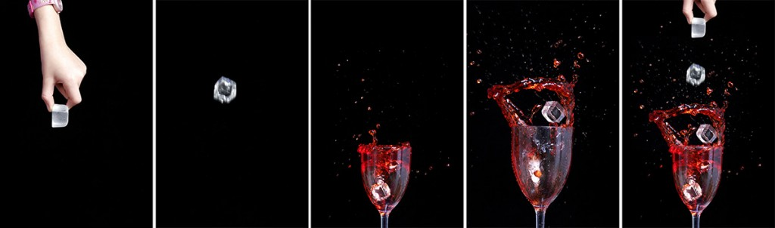

Gavin Hoey

