Canon T1i Menu Layout
The Canon T1i's menus are quite similar to those of the XSi, but there are a few changes. Since many readers may already be familiar with the XSi's menu system, we'll take a quick look at the primary differences.
One thing that will be apparent here is that many menus on the Canon T1i have more items on them than we saw on the XSi. Despite the increased density, we found the menus of the Canon T1i to be wonderfully readable: The super-high resolution of its LCD makes even small menu text very crisp.
Shooting Menu 1
Rebel XSi | Rebel T1i
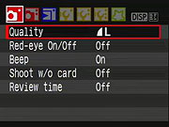 | 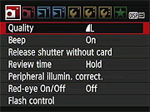
Changes here include the addition of Peripheral Illumination Correction (by which the Canon T1i can compensate for shading or vignetting in images), and a flash control sub-menu, which holds an extended range of options for flash operation. The ordering of some items has also been changed.

Shooting Menu 2
Rebel XSi | Rebel T1i
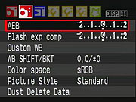 | 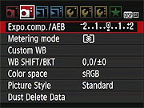
Auto Exposure Bracketing (AEB) has been changed to Expo.comp./AEB, and Flash exposure compensation is gone (moved to the Flash Control submenu of the first Shooting menu screen). Metering Mode has also been added here.

Playback Menu
Rebel XSi | Rebel T1i
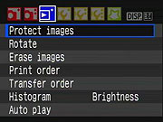 | 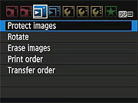
The Playback menu on the Canon T1i actually became somewhat simpler, as Histogram, Brightness, and Auto Play functions have been moved elsewhere.

Setup Menu 1
Rebel XSi | Rebel T1i
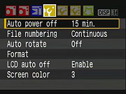 | 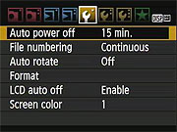
The Canon T1i's Setup Menu 1 is essentially identical, the only difference being that the four color schemes available under the Screen Color option are different from those on the XSi.

Setup Menu 2
Rebel XSi | Rebel T1i
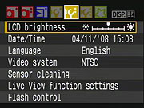 | 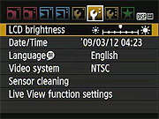
The Canon T1i's Setup Menu 2 is also essentially identical, the only obvious change being that Flash Control has moved to the first Shooting Menu screen. A speech bubble graphic now accompanies the Language menu item, making it easier to find if you accidentally change to a language that you cannot read.

Setup Menu 3
Rebel T1i
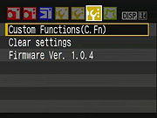 | 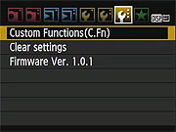
The Canon T1i's third Setup Menu page is identical to that of the XSi.

Custom Function Menu
Rebel XSi | Rebel T1i
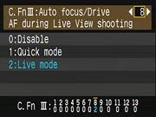 | 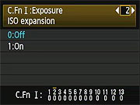
The Canon T1i has 13 custom function settings, as did the XSi before it, but the T1i's C.Fn. menu incorporates two changes relative to the earlier model:
- ISO expansion is now included. The normal ISO range extends to 3,200, with High ISO Expansion enabled, though, options of 6,400 and H are added, the H setting corresponding to an ISO level of 12,800.
- To make room for the ISO expansion option, the AF during Live View shooting option (previously C.Fn. 8) has been dropped from the C.Fn. menu, and moved instead to the Quick Menu in Live View shooting mode. (Where it makes much more sense, as this a function you'll probably want to change fairly frequently, depending on the type of subject you're shooting.)

My Menu
Rebel XSi
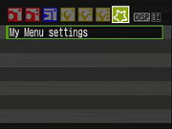 | 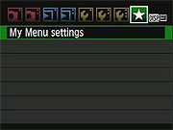
The Canon T1i's My Menu, where you can define and access your own most commonly used settings, is the same as on the XSi.

Canon Rebel T1i Menu Details
Record Menu 1:
Record Menu Options: Screen 1
Top-Level  Selection | Second-Level | Third-Level | Notes
Quality | - 4752 x 3168, Fine  - 4752 x 3168, Normal  - 3456 x 2304, Fine  - 3456 x 2304, Normal  - 2352 x 1568 Fine  - 2352 x 1568, Normal  - RAW + L/F JPEG  - RAW |  | Select image size and quality combination.
Beep | - On  - Off |  | Turns camera beep sounds on or off.
Release shutter without card | - Enable  - Disable |  | If enabled, the camera will fire the shutter even without a memory card installed.
Review time | - Off  - 2 sec.  - 4 sec.  - 8 sec.  - Hold |  | Enables an automatic image review after each shot. "Hold" keeps the image displayed until you half-press the shutter button.
Peripheral illumination correction | -Enable  -Disable |  | If on, the camera corrects for corner shading "vignetting" in JPEGs, depending on which lens is detected (therefore, probably won't work with third-party lenses).
Red-eye On/Off | - On  - Off |  | If On, Red-eye reduction lamp illuminates with every flash exposure.
Flash control | -Flash Firing | - Enable  - Disable | Controls a vast array of flash settings for both the internal flash and any attached external flash unit.
 | - Built-in Flash Func. Setting | - Flash Mode  - Shutter Sync  - Flash Exp. Comp.  - E-TTL II
 | - External Flash Func. Setting | - Flash Mode  - Shutter Sync  - FEB  - Flash Exp. Comp.  - E-TTL II  - Zoom
 | - External Flash C.Fn. Setting | - Enable  - Disable
 | - Clear Ext. Flash C.Fn. Set

Record Menu 2:
Record Menu Options: Screen 2
Top-Level  Selection | Second-Level | Third-Level | Notes
Exposure compensation / AEB (Auto Exposure Bracketing) | - Select EV variable |  | +/-2 EV in 1/3 or 1/2 steps; +/-4 EV scale for AEB.
Metering mode | - Evaluative  - Partial  - Spot  - Center-weighted
Custom WB | - Choose image for reference, then set white balance
White Balance SHIFT/BKT | - Set the color shift on a 2-dimensional grid (Green/Magenta, Blue/Amber)  - Choose bracket (+/-3 Magenta and Green, +/-3 Blue and Amber) |  | One level of correction is equal to 5 mireds of a color temperature conversion filter.
Color space | - sRGB  - Adobe RGB
Picture Style | - Standard  - Portrait  - Landscape  - Neutral  - Faithful  - Monochrome  - User Def. 1  - User Def. 2  - User Def. 3 | - Sharpness (arbitrary units from 0 to 7)  - Contrast (9 units from - to +)  - Saturation (9 units from - to +)  - Color Tone (9 units from - to +)
Dust Delete Data | - Cancel  - OK |  | Captures a reference image for the dust reduction system, showing where dust is present on the sensor. Dust shadows can then be automatically removed from the images when they're processed through Canon's software.

Playback Menu 1:
Playback Menu Options: Screen 1
Top-Level  Selection | Second-Level | Third-Level | Notes
Protect images | - Set |  | Sets or removes protection mark. Protected images can only be deleted by reformatting the memory card.
Rotate | - Set |  | Rotates selected image clockwise, either 90 or 270 degrees.
Erase images | - Select and erase images  - All images on card
Print order | - Sel. Image  - All image  - Set up |  | Marks images on the memory card for later printing on a DPOF (Digital Print Order Format) compatible printer.
Transfer order | - Sel. Image  - All image |  | For transferring images to a computer. (Computer must be running Canon's EOS Utility software.)

Playback Menu 2:
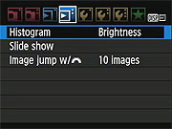
Playback Menu Options: Screen 2
Top-Level  Selection | Second-Level | Third-Level | Notes
Histogram | - Brightness  - RGB |  | RGB option displays individual histograms for each color channel, brightness shows only a single graph.
Slide show | - Select images | - All images  - Folder  - Date | Sets up Slide Show feature. Users can choose to play all folders, one folder, or just photos taken on a particular date. The Menu button stops playback.
 | - Setup | - Play time  - Repeat
 | - Start
Image jump w/ dial | - 1 image  - 10 images  - 100 images  - Date  - Movies  - Stills |  | Selects how image jump works using the Main Dial.

Setup Menu 1:
Setup Menu Options: Screen 1
Top-Level  Selection | Second-Level | Third-Level | Notes
Auto power off | - 30 sec.  - 1 min.  - 2 min.  - 4 min.  - 8 min.  - 15 min.  - Off |  | Amount of time to wait before automatically turning off to save power.
File numbering | - Continuous  - Auto Reset  - Manual Reset |  | Continuous numbers image files sequentially.  Auto Reset resets the numbering every time a card is formatted or a new card inserted.  Manual Reset resets numbering at any time to 0001.
Auto rotate | - On (Record, Display)  - On (Display)  - Off |  | Record, Display - vertical images are rotated on both the camera's LCD and on the computer. (In applications that understand "Rotate" tags in the files' EXIF headers.)  Display - vertical images are only rotated on the computer.
Format | - Cancel  - OK  - option for Low level format |  | Erases all files on card, even protected ones.
LCD auto off | - Enable  - Disable |  | Controls the sensor that turns off the LCD display when you bring the camera up to your eye.
Screen color | - Select from 4 screen color schemes  - OK

Setup Menu 2:
Setup Menu Options: Screen 2
Top-Level  Selection | Second-Level | Third-Level | Notes
LCD brightness | - Set brightness level from darkest to brightest |  | Seven brightness settings.
Date/Time | - Set Date  - Set Time  - Set Display Format
Language | - English  - German  - French  - Dutch  - Danish  - Portuguese  - Finnish  - Italian  - Norwegian  - Swedish  - Spanish  - Greek  - Russian  - Polish  - Hungarian  - Czech  - Simplified Chinese  - Traditional Chinese  - Korean  - Japanese  -Arabic  - Romanian  - Turkish  - Ukrainian  - Thai
Video system | - NTSC  - PAL
Sensor cleaning | - Auto cleaning | - Enable  - Disable | Auto cleaning options determines if sensor cleaning occurs automatically when power switch is turned off or on.
 | - Clean now | - Cancel  - OK
 | - Clean manually | - Cancel  - OK | OK triggers mirror to lock up so you can clean the sensor manually.
Live View function settings | - Live View shoot | - Enable  - Disable | Along with three types of autofocus ("Live" mode uses contrast-detect AF from image sensor data, "Face detect" mode adds face-detection, while "Quick" mode uses the dedicated phase-detect AF module), you can manually focus in Live View mode. Up to 10x magnification is available to assist in critical manual focusing.
 | - Grid display | - Off  - Grid 1  - Grid 2
 | - Metering timer | - 4 sec  - 16 sec  - 30 sec  - 1 min.  - 10 min.  - 30 min.
 | - AF mode | - Live mode  - Face detect live mode  - Quick mode

Setup Menu 3:
Setup Menu Options: Screen 3
Top-Level  Selection | Second-Level | Third-Level | Notes
Custom Functions | - Goes to Custom Function menu (See Below)
Clear Settings | - Clear all camera settings  - Clear all Custom Func. (C.Fn)  - Cancel
Firmware Version | - Update firmware version |  | Updates firmware version if a properly-prepared SD card is in place.

Custom Functions Sub-Menu:
Custom Functions
Top-Level  Selection | Second-Level | Third-Level | Notes
C.Fn I: Exposure  1: Exposure level increments | - 0: 1/3 stop  - 1: 1/2 stop
C.Fn I: Exposure  2: ISO Expansion | - 0: Off  - 1: On |  | When enabled, options of 6,400 and H are added, the H setting corresponding to an ISO level of 12,800.
C.Fn I: Exposure  3: Flash sync. speed in AV mode | - 0: Auto  - 1: 1/200-1/60sec Auto  - 2: 1/200 sec. (fixed) |  | Auto: Shutter speed may vary from 30 to 1/200 second.  1/200: Shutter speed is fixed at this setting.
C.Fn II: Image  4: Long exp. noise reduction | - 0: Off  - 1: Auto  - 2: On |  | Controls additional noise-reduction processing for exposures 1 second and longer.
C.Fn II: Image  5: High ISO speed noise reduct'n | - 0: Standard  - 1: Low  - 2: Strong  - 3: Disable |  | Enables additional noise-reduction. Applied at all ISOs, but particularly effective at reducing chroma noise at higher ISOs, or shadow noise at lower ISOs.
C.Fn II: Image  6: Highlight tone priority | - 0: Disable  - 1: Enable |  | Enables Highlight tone priority, which helps retain highlight detail in JPEGs. ISO range is 200-1600.
C.Fn II: Image  7: Auto Lighting Optimizer | - 0: Standard  - 1: Low  - 2: Strong  - 3: Disable |  | Enables Auto Lighting Optimizer which optimizes brightness and contrast for JPEGs automatically.
C.Fn III: Auto focus / Drive  8: AF assist beam firing | - 0: Enables  - 1: Disable  - 2: Only external flash emits |  | Turns AF assist beam on or off, determines whether it comes from the built-in flash or from an external strobe unit.
C.Fn III: Auto focus / Drive  9: Mirror lockup | - 0: Disable  - 1: Enable |  | Raises the mirror with the first press of the shutter button, releases the shutter with the second. (Useful for reducing mirror shake when using a tripod and remote release with a long telephoto or macro lens.)
C.Fn IV: Operation / Others  10: Shutter/AE lock button | - 0: AF/AE lock  - 1: AE lock/AF  - 2: AF/AF lock, no AE lock  - 3: AE/AF, no AE lock |  | Determines the effect of the Shutter and AE lock buttons:  0: * button locks AF and exposure.  1: * button autofocuses, shutter half-press locks exposure.  2: * button stops AF operation momentarily in AI Servo mode, exposure set when the shutter is released.  3: * button stops/starts AI Servo operation in AI Servo mode, exposure set when the shutter is released.
C.Fn IV: Operation / Others  11: SET button when shooting | - 0: Quick Control Screen  - 1: Image quality  - 2: Flash exposure comp.  - 3: LCD monitor On/Off  - 4: Menu display  - 5: Disabled |  | Controls the functions of the SET button in record mode.
C.Fn IV: Operation / Others  12: LCD display when power on | - 0: Display  - 1: Retain power OFF status |  | Controls whether the LCD active state is remembered or forces it on when camera is powered-up.
C.Fn IV: Operation / Others  13: Add original decision data | - 0: Off  - 1: On |  | Add original decision data On option appends data to verify an original image. Original Data Security Kit (OSK-E3) required to verify image is original is sold separately

My Menu:
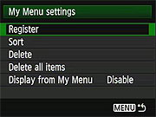
My Menu Options
Top-Level  Selection | Second-Level | Third-Level | Notes
Register | - (Full list of options that can exist in My Menu) |  | Register your own frequently used menu items and custom functions to appear in My Menu.
Sort |  |  | Changes the order of registered items in My Menu.
Delete
Delete all items
Display from My Menu | - Enable  - Disable |  | When Enabled, the My Menu tab is displayed first when pressing the Menu button.

