David Hockney Photo Assignment
Your assignment is to create a photo collage construction, in the style of artist David Hockney, that emphasizes space.
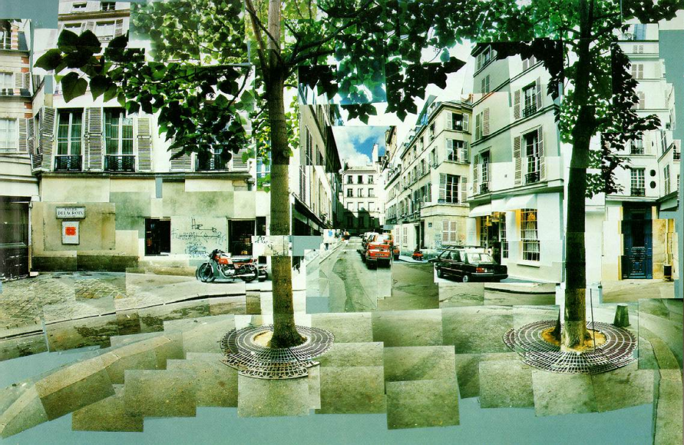
1. Research Hockney on the internet, look for other examples of his work. Choose a subject that can be photographed "in pieces" and which will make sense when you reconstruct it.
2. You must incorporate at least thirty-five images into your photo collage construction. You may manipulate your images to best reflect the concepts described in this assignment.
3. To begin construction of your photo design, create a new blank page that is 24" wide by 18" tall at 300 ppi resolution. You will paste your image pieces onto this blank canvas to construct your image. Be warned! You will have to reduce the size of each piece -- they will be too large to fit all of them onto the blank page.
4. Create and compose 2 separate Images this way. Make sure to have depth in your photographs, experiment stepping in to the images as you are taking them.

