Depth of Field Assignment

Changing the aperture affects the depth of field. Depth of field is the variable range in a photo that is acceptably in focus. The decision to have something in or out of focus is an artistic one, and therefore needs to be considered carefully as it will change the meaning of a photo.

In the project you will place five objects at one-foot intervals and slightly staggered so that you can see all the objects when sighted down. Use the camera in aperture priority or “AV” and select an ISO setting appropriate for your lighting conditions, and then don’t touch the ISO again (remember what the consequences of changing the ISO are?). The closest object should be in the lower right or left of the frame and the furthest object moving up diagonally in the frame. Get close to the first object, 8 - 10 inches, and auto-focus on the third object using the red target points in the viewfinder. Target carefully and then switch the lens to manual focus, so the that lens doesn’t accidentally re-focus on a different point.

Start at the highest available aperture, probably F22, F29 or F32. Confirm that the light meter is on “0” and take your first shot. Then, open up the aperture two clicks and take another shot. Continue this until you have reached the lowest aperture setting (largest opening) on the lens (possibly F3.5).

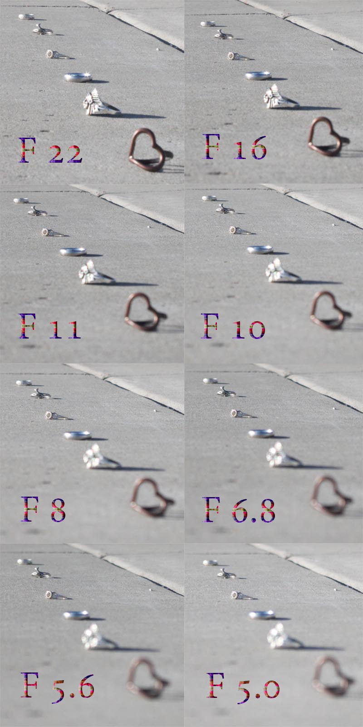

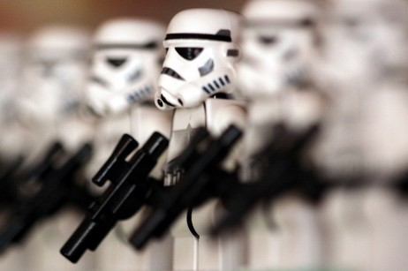

Create a canvas that will fit eight of your pictures,

with a maximum size of 11” wide by 17” tall and a

dpi of 300. Arrange all your pictures on the

canvas so they are in the order taken and the F-Stop

is listed on each photo and easy for anybody to

understand and comprehend.