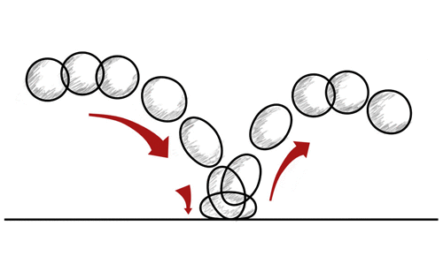
Follow the Bouncing Ball

The Basics: Capture video of a ball…
- Being put into motion
- Bouncing or rolling throughout an environment
- Coming to rest
Once you have captured plenty of raw video, edit it in Adobe Premiere into a logical progression of movement with an understandable beginning, middle and end.
Things to consider:
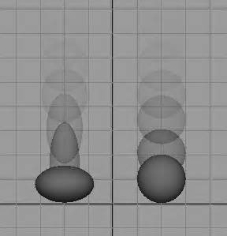
What type of ball should you use?
What kind of movement would you expect from that ball?
What is an interesting way of putting the ball in motion?
Does the ball have any character traits?
How would you reflect those traits on video?
How would music or sound effect help improve the video?
What roll should people play?
How do you tell your story without dialogue?
What should the establishing shot be?
Are you holding the viewers interest?
Does the ball come to rest in an interesting way?
This is an individual assignment, however you will probably need the help of others in order to capture footage. Be willing to be a supportive classmate!
Important: Review the “Camera Angles Diagram” and “Camera Shots, Angles and Movement” handouts, and then incorporate those techniques into your video.

