Freeze Action
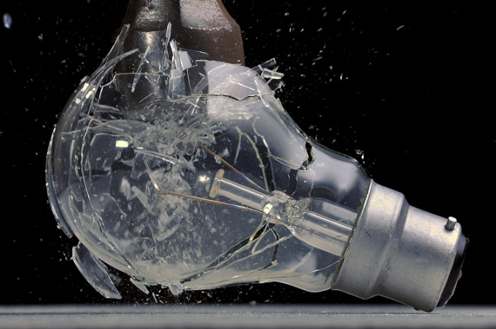
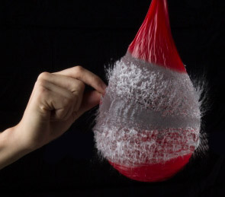
The Goal of this assignment is to capture a moment in time that the human eye and mind usually can’t or does not perceive. The minute details that happen in an instant and are gone just as fast can provide an insight to a world we don’t usually get to see. The structure and weaknesses of an item or the elegant shape of a splash found in freeze action photography can offer a moment artistic interest unlike any other photographic technique.

The Basics:
Find an item that would look interesting when put under stress by being dropped, smashed, hit, crushed, squished, popped, or whatever else that would make a good photo.
Settings:
Set the camera on time priority (Tv). The shutter speed needs to be as fast as possible, but it all depends on the speed of the object. Most items shot at 1/400 should be OK, but if you can get it faster and still have a balanced light meter then shoot faster. 1/1000 would be great. Because we are capturing detail, we cannot have too much noise. Do not go above 800 ISO unless you have no choice. Lower would be even better. Let the camera decide on the F-stop, but be aware that if the lens is wide open, your depth of field will be small. Either way, you should pre-focus to the impact point and set the lens to manual focus so it does not change.
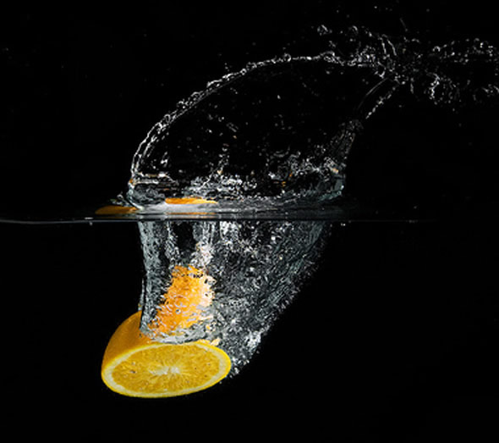
Things to Consider:
1. How many items will you need before you get an image that looks good?
2. What color do you want the background? Black because you are dealing with something clear?
3. If the item is being dropped, does the color of the surface that it is being dropped on mater to you?
4. How can you fill the frame with the subject? Closer is usually better.
5. Is there an interesting perspective that can be achieved by moving the camera to a different location?
6. Do you need to artificially light the scene? There is a good chance that the answer is yes. If so, let me know.
Warning:
DO NOT do anything to get yourself hurt or the camera damaged. (Not necessarily in that order). Perhaps a clear shield or goggles would be appropriate depending on what it is you are capturing.

