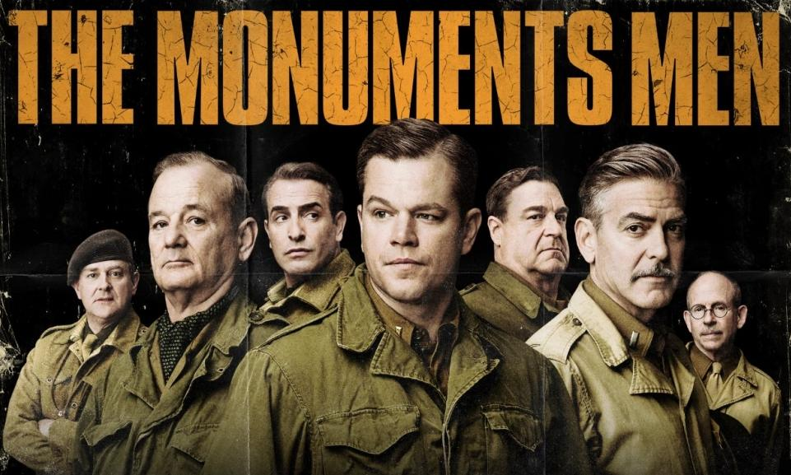
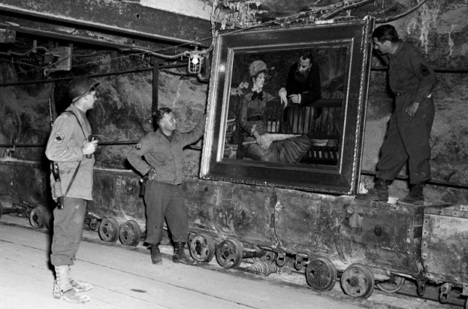

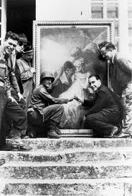

Do you think trading lives for artwork was worth it? Why?
Answer:

What was the reason behind putting effort into recovering and returning stolen artwork?

Answer:

The nazis went to great lengths to collect the art, yet were willing to destroy it once they realized they couldn't keep it. What does that say about how the Nazis valued art?
Answer:

