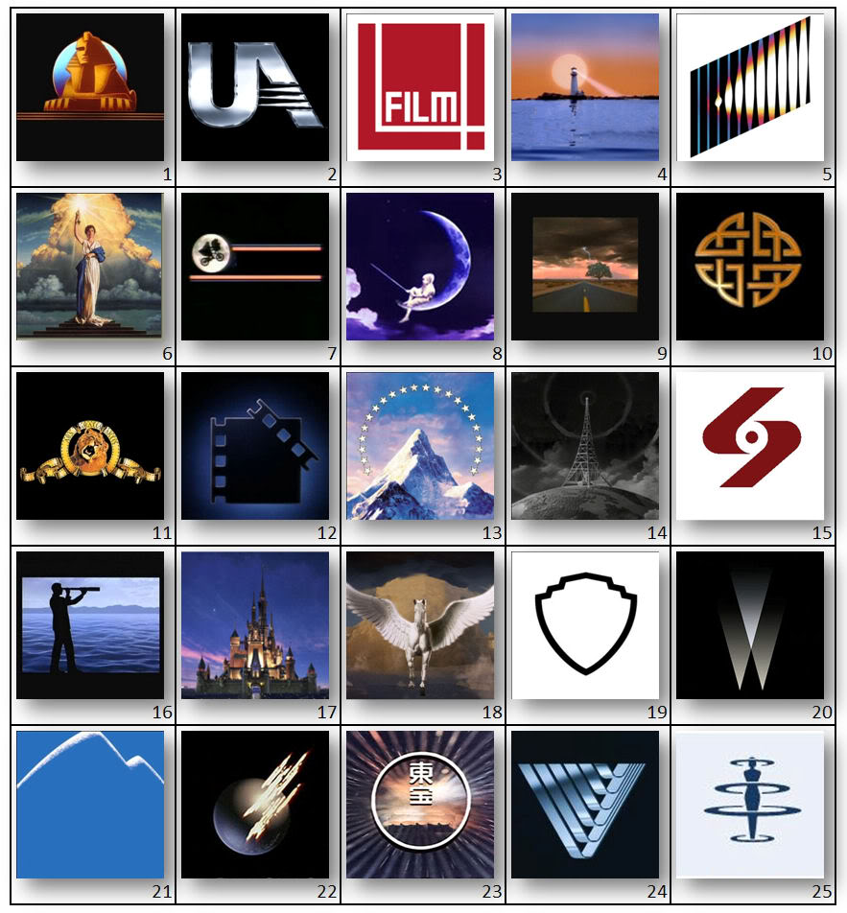
Movie Studio Logos

STEP 1: Fill in the names of the 25 movie studios above into the text boxes provided. This is an individual assignment so do not share answers with other students.
STEP 2: Using the next page on this form, pick your top three logos and do an evaluation of each. Explain why you picked them and what it is about them that makes them both artistically interesting and reflective of the particular studio that it represents. The more complete your answer the better!
STEP 3: Now pick three logos that missed the mark. Where did they go wrong? What is it about them that doesn’t work? How would you change them to better fit the studio that the represent?

3 Best:
1.

2.

3.

3 Worst:
1.

2.

3.

