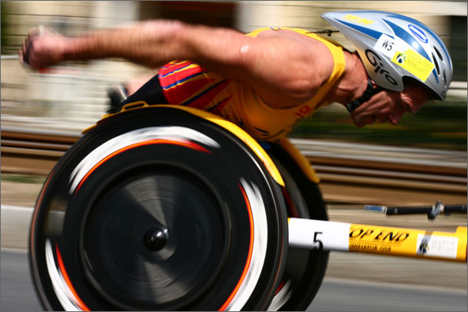
Panning

The goal of using the panning technique is to capture movement. So much time is spent trying to eliminate blur from photographs yet this is a technique where it is embraced and encouraged.
There are two parts of this assignment. The practice of learning the proper settings and technique and the final artistically relevant picture taken once the settings and technique is mastered.
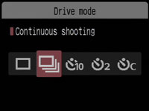
Settings:
Put the lens on Auto Focus (AF).
Move the Drive mode from “Single shooting” to “Continuous shooting”. This allows the camera to take multiple shots by pressing and holding down the shutter release button.
Move the AF mode from “One Shot” to “AI Servo”. This allows the lens to continuously focus on a subject during continuous shooting mode.
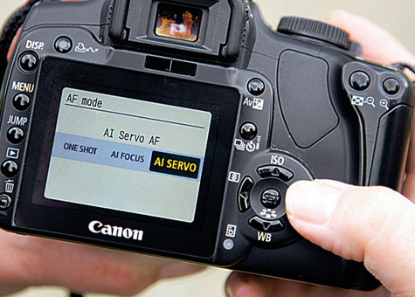
Set the ISO at 200, although you have the freedom to change it depending on lighting conditions.
Set the camera on Time Priority (Tv). This allows you to change the shutter speed as needed depending on the amount of blur you want to capture. Start at 1/25 of a second and work up and down from that point. The camera will automatically adjust the aperture, you just need to be aware of the light meter and the consequences of aperture as it relates to depth of field.
Time to practice, practice, practice. Find and photograph on campus subjects that are moving and perfect your technique in anticipation of capturing your final photographic masterpiece.

Final Shot:
Take what you have learned and apply it to an artistically relevant subject. Nobody is interested in a golf cart driving by. Consider what would be appealing to a viewer and capture it. It might take time and require you to check out a camera overnight. Minor adjustments can be made in Photoshop as needed but the bulk of the effort is made in the capturing of the image. Turn into drop-off fold in required format for grading.

