COMPOSITION ASSIGNMENT

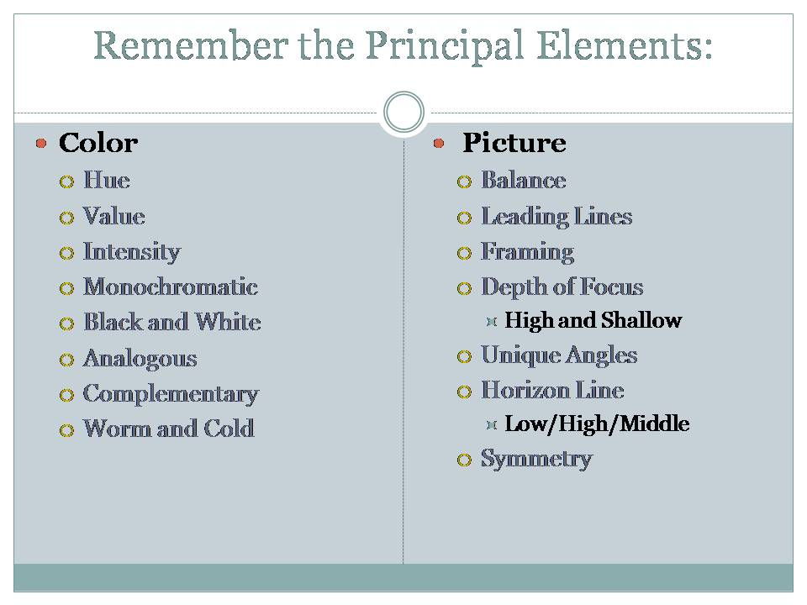

Directions:
- Work in manual Settings
- Focus your subjects in Manual Mode
- FIND SOMETHING INTERESTING TO PHOTOGRAPH!!
- Get Close to the Foreground
- Label each image with the Composition Guidelines you are trying to show
- PHOTOGRAPHS (14 Total)
  - 1 Photograph with the Rule of Thirds
  - 1 Photograph with Balancing Elements
  - 1 Indoor with Leading Lines
  - 1 Outdoor Photograph with Leading Lines
  - 1 Photograph with Symmetry
  - 1 Photograph with Cool Color Dominance
  - 1 Photograph with Warm Color Dominance
  - 2 photograph where the subject is Framed
    - Using People
    - Using another object
  - 2 Photographs using Unique Angles.
  - 1 Photograph where the Horizon Line matters (Low, middle,high)

CHALLENGE YOUR SELF (new Principal)
- 2 photographs of Rhythm - Rhythm is created when one or more elements of design are used repeatedly to create a feeling of organized movement. Variety is essential to keep rhythm exciting and active, and moving the viewer around the artwork. Rhythm creates a mood like music or dancing.

Example of Rhythm:
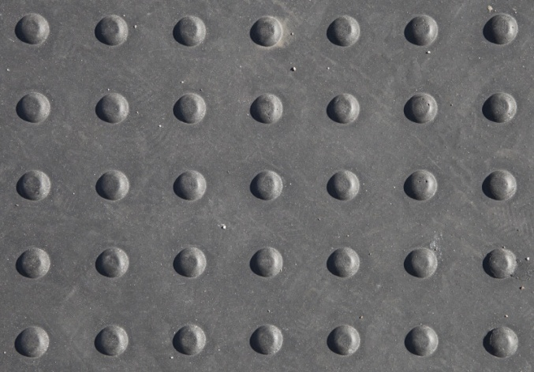

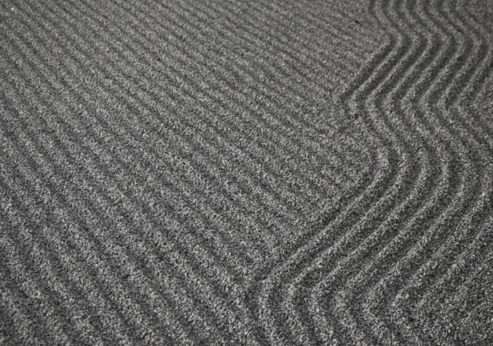

Once you have all the photographs, open each one in Photoshop on a canvas that is 12” wide x 16” tall at 200 dpi, and use the adjustments to enhance the photographs one at a time. Then add a layer style that makes them look like an actual photograph (see below). Feel free to adjust this to taste. Once you have one done, you can right click on it and select “copy layer style”, select the other layers using the shift key and right click to select “paste layer style” and the effect will be added to the other 13 pictures. Arrange the pictures in an interesting way so that there is some overlapping. Add a gradient to the background layer by selecting colors that are common to your pictures using the eye dropper. Lastly, label each picture with the category it represents, example: Symmetry, using an appropriate font. Turn in to the drop off folder with the required name format.

