Photoshop
Layer Style
The Basics:
1. Make 13 layers that are comprised of either Text or Images.
2. Apply one each of the 13 options under layer>layer style in the order that they appear.
3. Make the first one (Drop Shadow) your first and last name
4. Canvas size should be 8 x 10 resolution set at 200dpi.
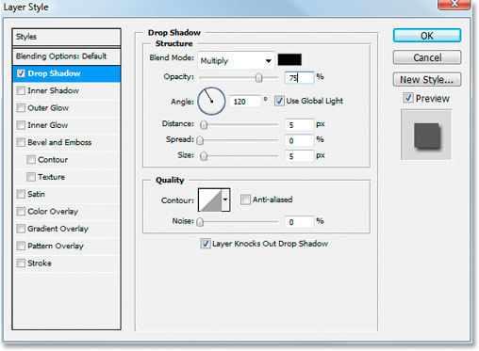

Example:
Requirements: Play with every button and every slider on each of the 13 layer styles!
Warning : Some layer styles are better suited to text and some to images. Try both if you are unsure.

