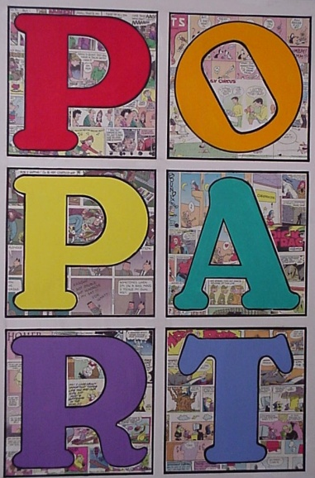
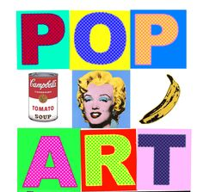

Andy Warhol
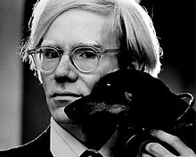
Birth name | Andrew Warhola
Born | August 6, 1928  Pittsburgh, Pennsylvania, United States
Died | February 22, 1987 (aged 58)  New York City, U.S.
Field | Printmaking, painting, cinema, photography
Movement | Pop art
Works | Chelsea Girls (1966 film)  Exploding Plastic Inevitable (1966 event)  Campbell's Soup Cans (1962 painting)

Overview:
The goal is to produce an artistically relevant self portrait inspired by the work of Pop Art artists such as Andy Warhol.
This is a two step process where you will, 1) Capture a usable image, and 2) Use Photoshop to manipulate that image to reflect the Pop Art style, especially its color.
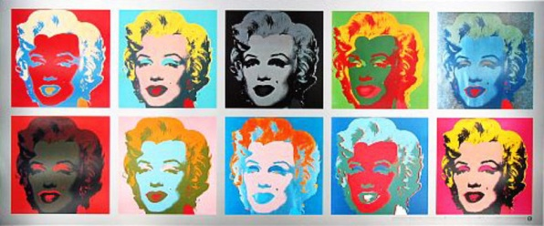
Andy Warhol achieved a similar look through the printmaking process and provided the art world with some of its most iconic images during the Pop Art movement.

For more info on Andy Warhol visit Wikipedia - link
Step 1) Capture a photo of yourself from your shoulders to the top of your head. Do not cut off the top of your head or any hair. Make sure this is done using harsh lighting so that there are either shadows cast across your face or at least significant contrast or change in skin lighting between different areas on your face.
Step 2) Open Picture in Photoshop and crop as needed. Use Image>Adjustments> Brightness/Contrast to increase the effect of shading on your face.
Step 3) Use Image>Adjustments> Posterize and set the level at 2. This should have the effect of turning your photo into 4 colors. Red, yellow, black, and white.
Step 4) Use Filter>Noise>Median and set the radius to between 5 and 12 pixels depending on your taste. Be sure not lose the detail in your face that makes you unique, but get rid of some of the distracting fuzzy areas.

Step 5) Use the magic wand to select a color (you may need to change the tolerance to get what you want) . Make sure you have unchecked the “contiguous” box at the top so it selects all areas that have that color and not just the ones connected to the area you clicked. Now hit Edit>Copy, create a new layer, and hit Edit>Paste. You should now have a layer that includes that exclusive color. Do the same thing for all colors (red, black, and yellow) but not for white. Each color should have its own layer. Get rid of the background layer.
Step 6) Create a fourth layer and put it below the other 3. Use the gradient tool (Under the paint bucket) to add an interesting gradient to the blank layer.
Step 7) Go to each of the other layers and replace the existing colors by selecting the old color using the magic wand and filling with an alternate color, by using the paint bucket or the gradient tool. Take time in doing this and put a lot of thought into what colors work well together and best reflect your personality.
Step 8) Add your name to the piece in an appropriate location, and add some depth to the font by using any of the selections under Layer>layer style.
Step 9) Turn in to the drop off folder for grading using the proper file name.

